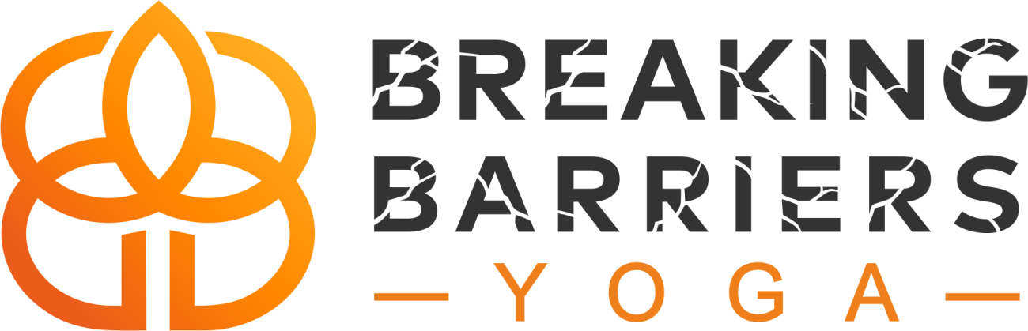

Online Classes Start Saturday, March 21st

FREE LIVE STREAMED CLASSES EVERY SATURDAY

1:00-2:00pm

www.breakingbarriersyoga.org/schedule

or use the Wellness Living Achieve app 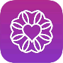

How does it work?
Step 1: Create an account on Breaking Barriers Yoga website (if you don’t already have one) and sign up for a class online.
Step 2: Download ZOOM on your phone, tablet, or computer and create a free account
Step 3: You will receive an email with the ZOOM link to join before class begins from kendal@yogabodyshop.com.
Step 4: How to prepare
- Arrive online 5-10 minutes early
- Set your device 4 feet away from the top of your mat
- Have your mat, block, and water with you
- Set up in a location with no distractions and noise. This is your time!
- Optional: have your own music ready for savasana (spotify, pandora, etc.) Live stream music quality is poor. All participants will be muted during savasana.
Step 5: Enjoy your yoga practice from home while staying connected to your community! Standing together sets us apart!
If you have issues accessing your class, email kendal@yogabodyshop.com.
Lets continue creating connection!

